# Temperatuursensor

<https://github.com/Swendude/kwhm-library/blob/master/README.md#temperatuursensor>

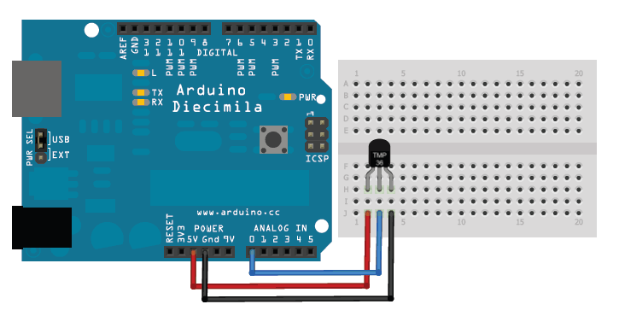

# Afstandsensor

<https://github.com/Swendude/kwhm-library/blob/master/README.md#afstandsensor>

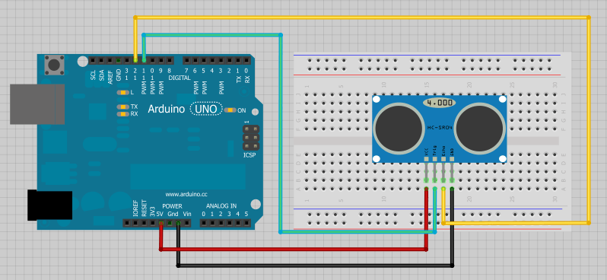

# Bodemvochtsensor

<https://github.com/Swendude/kwhm-library/blob/master/README.md#bodemvochtigheid>

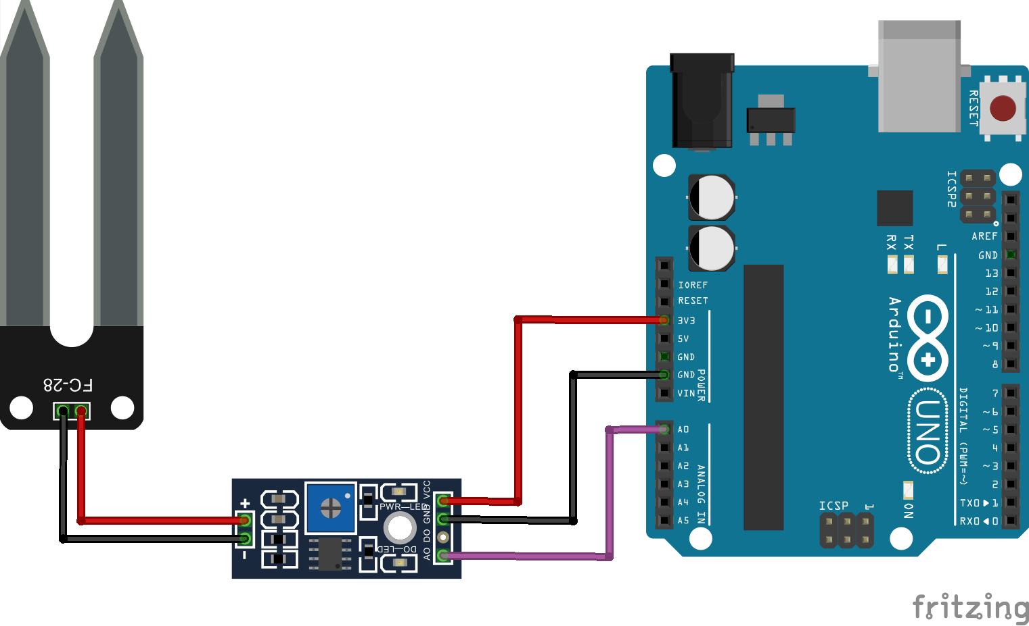

# Knop

<https://github.com/Swendude/kwhm-library/blob/master/README.md#knoppen>

